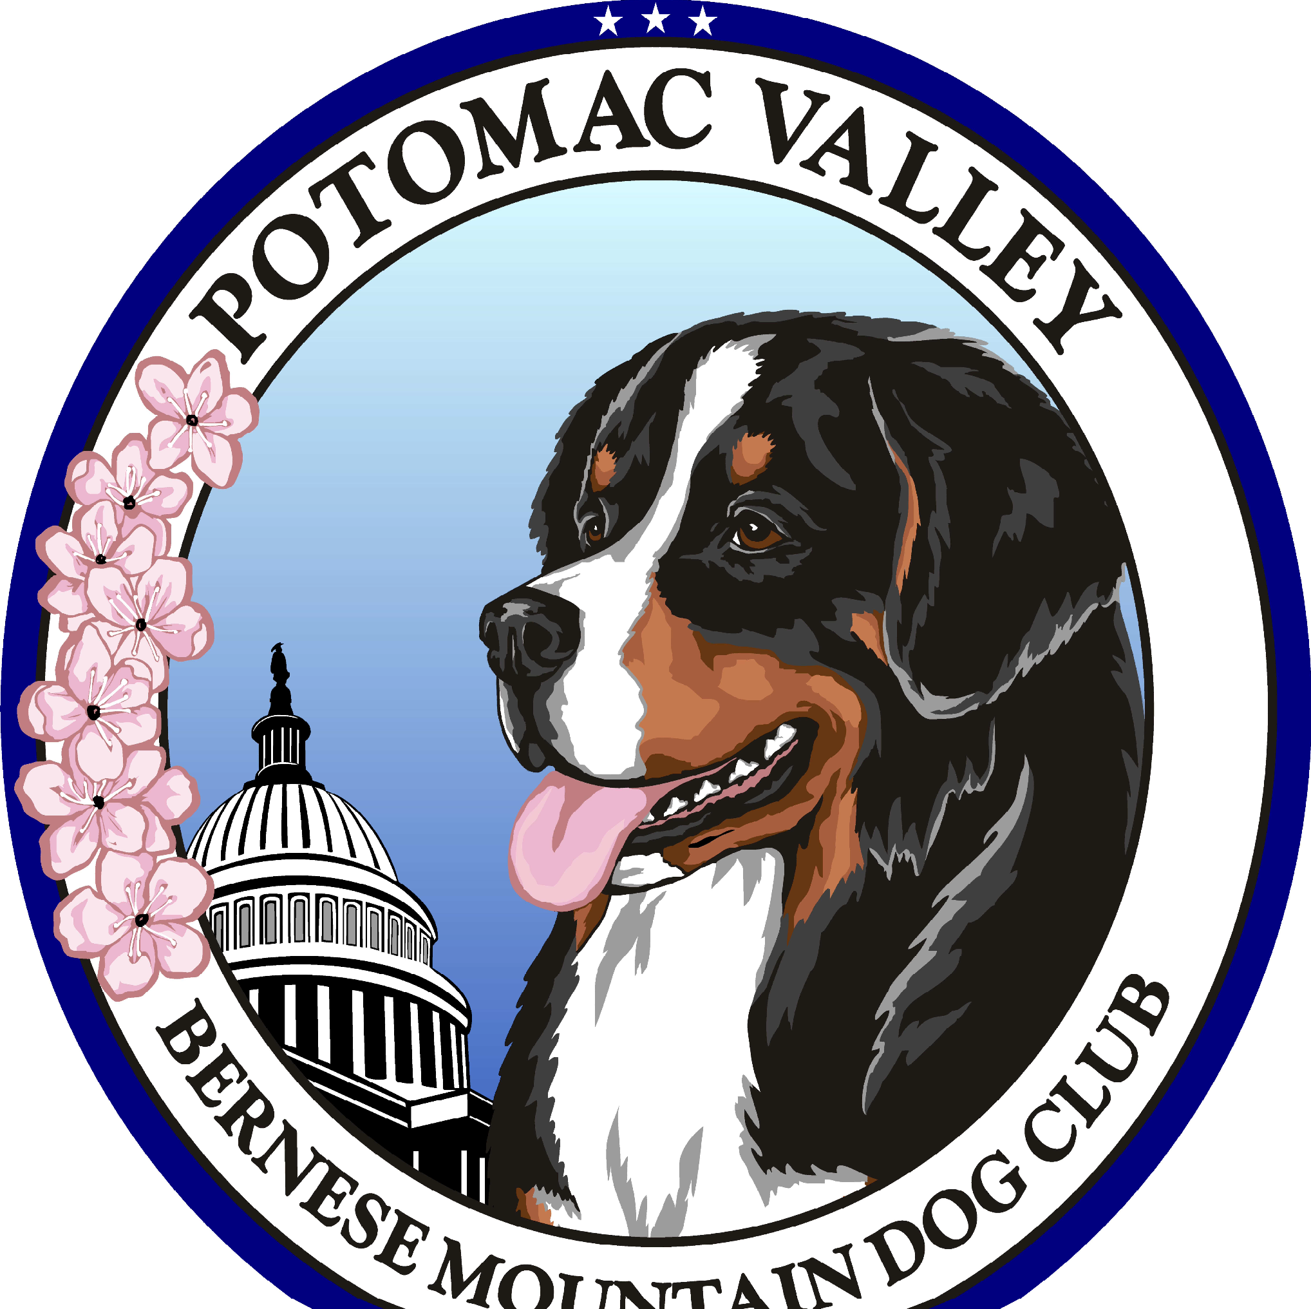

Potomac Valley Bernese Mountain Dog Club, Inc.

Information for People Interested in Rescue Dogs

Thank you for contacting our Club about the rescue of Bernese Mountain Dogs. We put people in touch with others who have a dog they want to re-home, or organizations, such as dog shelters, which happen to have a Bernese Mountain Dog for adoption. We do not evaluate the prospective dog, but strive to gather as much information about the dog as possible. We do not recommend any dog to anyone. That responsibility rests solely between the new owner and the previous owner. We merely inform people who have contacted us with an interest in getting a rescue dog where a dog is available, and pass on the information we have about the dog. The interested party then takes on all responsibility of determining whether or not the specific dog is suitable.

Often taking a rescue dog into one’s home is not an easy process. There may be health problems with a dog that has been neglected that might result in vet bills for the new owner. We don’t refer dogs with any known aggression issues, but there may be behavioral problems that arise because of a change in the dog’s environment. Most organizations require having the dog neutered or spayed, an expense borne by the new owner. While our club does not charge a fee to help you find a dog, some make a voluntary donation to our rescue fund.

It usually takes an experienced dog person many weeks to properly evaluate a dog put up for adoption, and, in most cases, that evaluation has not been accomplished before that dog comes to your home. Of course, if you have extensive experience in evaluating and retraining dogs, then you know all of this and understand what you are getting into, but for the rest of us, learning as much as one can about the animal BEFORE the transfer is very important. Don’t be afraid to ask any questions. Read as much as you can beforehand and write down your questions to ask the owner or organization. You are dealing with a live animal and that animal’s future depends on your knowledge and dedication. A rescue situation almost always requires a long-term commitment from the new owner.

There is a form attached that we ask all prospective owners of rescue dogs to fill out before they are placed on our list. Please fill it out, sign it and return it to the address on the form. You will then be placed on our list. If you find a dog by some other means, it would be appreciated if you let us know so we can remove your name from the waitlist.

The Potomac Valley Bernese Mountain Dog Club, Inc. is a good organization to join if you have a Bernese Mountain Dog. There are many members who are active in the breed and who can be a great source of help in all kinds of subjects about the breed. Our website at http://www.pvbmdc.org/ contains a lot of good information as well as the Bernese Mountain Dog Club of America website at http://www.bmdca.org/. The section entitled “BMD Info Series” on the BMDCA website should not be missed.

Thank you for your interest in re-homing Bernese Mountain Dogs. We hope that your interest can be translated into providing a needed home for one of our beloved Berners.

Rescue Form
This form is to be filled out by people interested in receiving information from the Potomac Valley Bernese Mountain Dog Club, Inc. about Bernese Mountain Dogs available for adoption

Please fill out this form, sign it signifying that you have read the cover letter and agree to have this information sent to anyone or any organization having a dog available for rescue or re-homing. Send the completed form via USPS to our rescue coordinator:
Katherine Skerl
P.O. Box 785 Lancaster, VA 22503 kskerl@focus-corp.com or
katherine@queenstownfinebernese.com
Name:
Address:
Telephone No: Cell No:
E-mail address:
Are you a previous Bernese Mountain Dog owner? (Circle one) Yes No
Number of adults in the house =
Number of Children/Ages in the house =
Will the dog have adult supervision during the day? (Circle one) Yes No
If No, average time dog will be alone and how dog will be provided for if necessary.
Type of residence (circle one): Apt. Townhouse Condo Single Family Duplex
Size of yard:
Size of Fenced area and fence’s height:
Dogs or other animals in household (number and type): Spayed/Neutered?

Name/Phone Number of Vet?
Gender Preference (circle one): | Male | Female | No Preference
Will your dog be an (circle one) | Outside | Inside | dog?
Past experience with dogs:
Why do you want a Bernese Mountain Dog?
Past experience with animals other than dogs:

I have read the Potomac Valley Bernese Mountain Dog Club Policy Guidelines and Rescue Form and understand the limited role that the Club has in the rehoming of a Bernese Mountain Dog. Further, I hold Potomac Valley Bernese Mountain Dog Club and its members and officers harmless from any and all liability, costs, and expenses arising as a result of this activity, including but not limited to injury or death of a dog, or bodily injury or death of any person, and damage to property of any kind.

Signature
Date
Print Name

