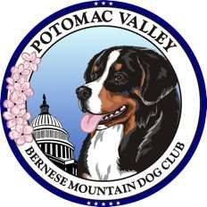
Potomac Valley Bernese Mountain Dog Club

PVBMDC Dues for 2026 are due January 1, 2026

Please make checks payable to PVBMDC **We have discontinued payments by Zelle and PayPal**
You may pay in cash or check along with the form at the Dec. 6, 2025, meeting or you can mail the form and check to:
PVBMDC Treasurer 2222 Pleasant View Rd Adamstown, MD 21710
We have several different types of membership: Regular, Associate, Junior, and Household (reduced dues for additional members living at the same address) – Please check off type!
Dues for First member in Household: Regular: $25 □ Associate: $20 □ Dues:
1st Household Member’s Name: Email:

Dues for Additional Members in same Household: Regular: $15 □ Associate: $10 □ Dues: Additional Household Member’s Name: Email: Dues for Junior Member: $10 □ Dues:
Junior Member’s Name: opt Email:

 | Total Dues:
 | Rescue Donation:
No Changes New Mailing Address | Trophy Donation:
 | Total Check Enclosed:
Check Number:
Date:

Primary Contact PHONE: Primary Contact E-MAIL
If you wish to CHANGE YOUR MEMBERSHIP TYPE at this time, please SIGN THIS REQUEST.
Dear Club Secretary:
Please change my membership to Associate Member effective Jan 1, 2026. Signed
OR
Please change my membership to Regular Member effective Jan 1, 2026. Signed
********************************************************************************************************************************************* PVBMDC By-Laws state that Members may elect to receive E-Mail notification of club meetings, dues notices and other special notices. If you have not already authorized receiving communications via the PV members email list in lieu of US Postal Service mail, please sign below to authorize.
Member Signature (s) Date

Dues Form Revised 10/15/2025 AUDIT ONLY - Check # Amt Date Rcvd

